**Team 2 “Swordsmith” Prototyping**

Blake Schlesinger

**Introduction**

This report will cover the individual blocks including blade and grip design, battery with low voltage cut-off circuit, charger, and regulator. Here is the Functional Block Diagram of the team followed by the blocks I am responsible for.

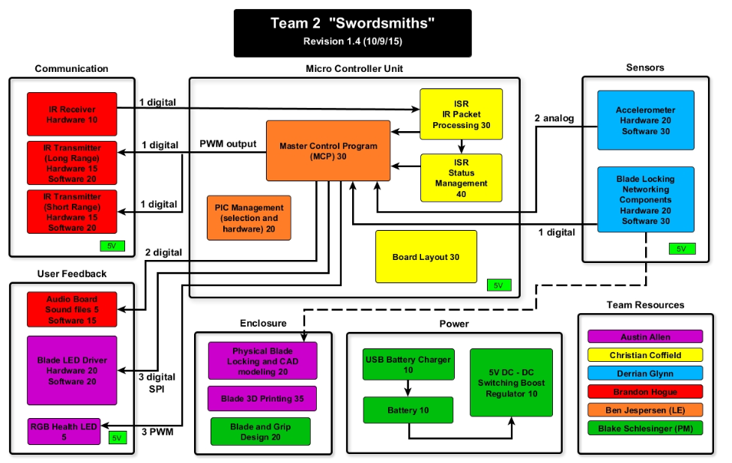

**Individual Responsibility**

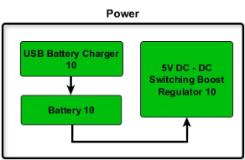 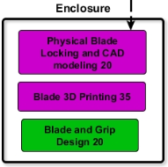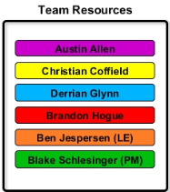

**Blade and Grip Design**

This block encompasses the design and building the basic parts of the blade to house the electronics.

**Materials**:

1x3 inch wood planks.

Composite fiberglass hockey sticks

3D printing filament.

\***No parts numbers for blade grip materials since all were already in possession and were not purchased**.

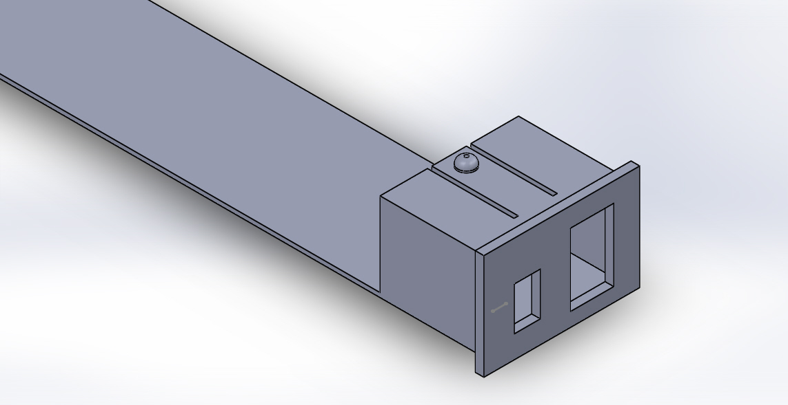

Figure1. Solid Works model for end cap of blade grip.

**Power**

This section includes the battery with LVC, charger, and regulator blocks. Simulations were conducted to show that the minimum requirements were met even under extreme conditions.

**Parts List:**

**Battery**

<http://hobbyking.com/hobbyking/store/__57282__Walkera_3_7V_1600mAh_LiPoly_Replacement_Battery_for_QR_Y100.html>

Specs: **Voltage:** 3.7V **Capacity:**1600mAh**Discharge Plug:**JST **Dimensions:**78x25x11mm **Weight:** 38g

**USB Charger**

<https://www.sparkfun.com/products/10401>

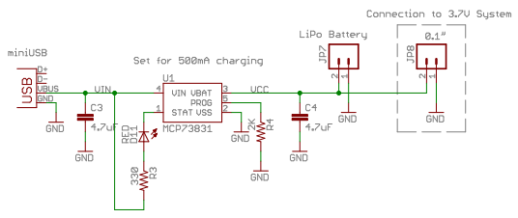

**Dimensions:**29.4x10.8mm

**Low Voltage Cut-off Protection Circuit**

<http://www.batteryjunction.com/tenergy-pcb-3v7-rnd-32002.html>

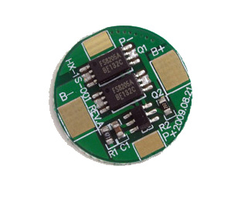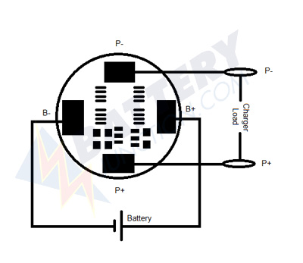

**Switch Mode Power Supply “Buck/Boost” Regulator** (being used in “Boost” mode)

<https://www.pololu.com/product/2564>

## Dimensions

|  |  |
| --- | --- |
| **Size:** | **0.35″ × 0.45″ × 0.1″**[1](https://www.pololu.com/product/2564/specs#note1) |
| **Weight:** | **0.4 g**[1](https://www.pololu.com/product/2564/specs#note1) |

## General specifications

|  |  |
| --- | --- |
| **Minimum operating voltage:** | **0.5 V** |
| **Maximum operating voltage:** | **5.5 V** |
| **Maximum input current:** | **1.2 A**[2](https://www.pololu.com/product/2564/specs#note2) |
| **Output voltage:** | **5 V** |
| **Reverse voltage protection?:** | **N** |
| **Maximum quiescent current:** | **1 mA**[3](https://www.pololu.com/product/2564/specs#note3) |

## Identifying markings

|  |  |
| --- | --- |
| **PCB dev codes:** | **reg12b** |
| **Other PCB markings:** | **0J7517** |

## Notes:

1. **Without included optional headers.**
2. **Regulator may overheat at lower input currents when VIN is much lower than VOUT. Available output current is a function of VIN, VOUT, and the regulator efficiency.**
3. **The highest quiescent currents occur at very low input voltages; for most of the input voltage range, the quiescent current is well below 1 mA.**

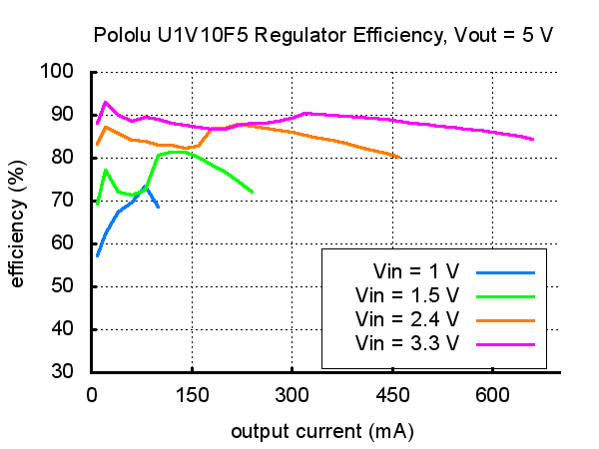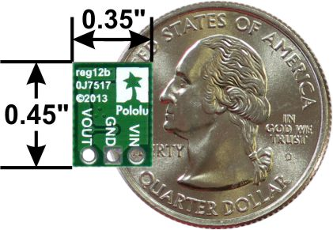

**Power ON Switch**

<http://www.digikey.com/product-detail/en/PRK22J5DBBNN/CH865-ND/1083858>

**Battery**:

The first of two battery tests is a discharge while monitoring the voltage of the LiPo cell to track the time until the cell reached its low voltage cut-off.

Conditions:

1. Uncycled fully charged single cell LiPo
2. 10 ohm power resistor as simulated load to draw approximately 500mA from the 5V regulator.
3. Load driven through LVC protection board and 5V SMPS regulator in “boost” mode.

There were 29 points taken in total being 5 minute intervals resulting in 145 minutes total. Dividing by 60 results in a run time of 2 hours and 25 minutes exceeding the requirement for the Omega blade.Upon conducting the second test an measuring current draw from the battery, it was determined that actual current draw was 750mA initially and rose steadily to 1.2A. As the actual current draw compared to the expected theoretical was determined in a later test, the regulator no doubt survived its maw current rating add a little more for a significant amount of time.

The second battery test was also a discharge while monitoring the current being drawn from the battery. Regardless whether the battery reached the low voltage cut-off point, the test was intentionally terminated early since the current reading from the multimeter showed in excess of 1.2A which is the max rating of the boost regulator.

The past two graphs shown of voltage and current VS time is logical since the current rises as the voltage falls to maintain power level.

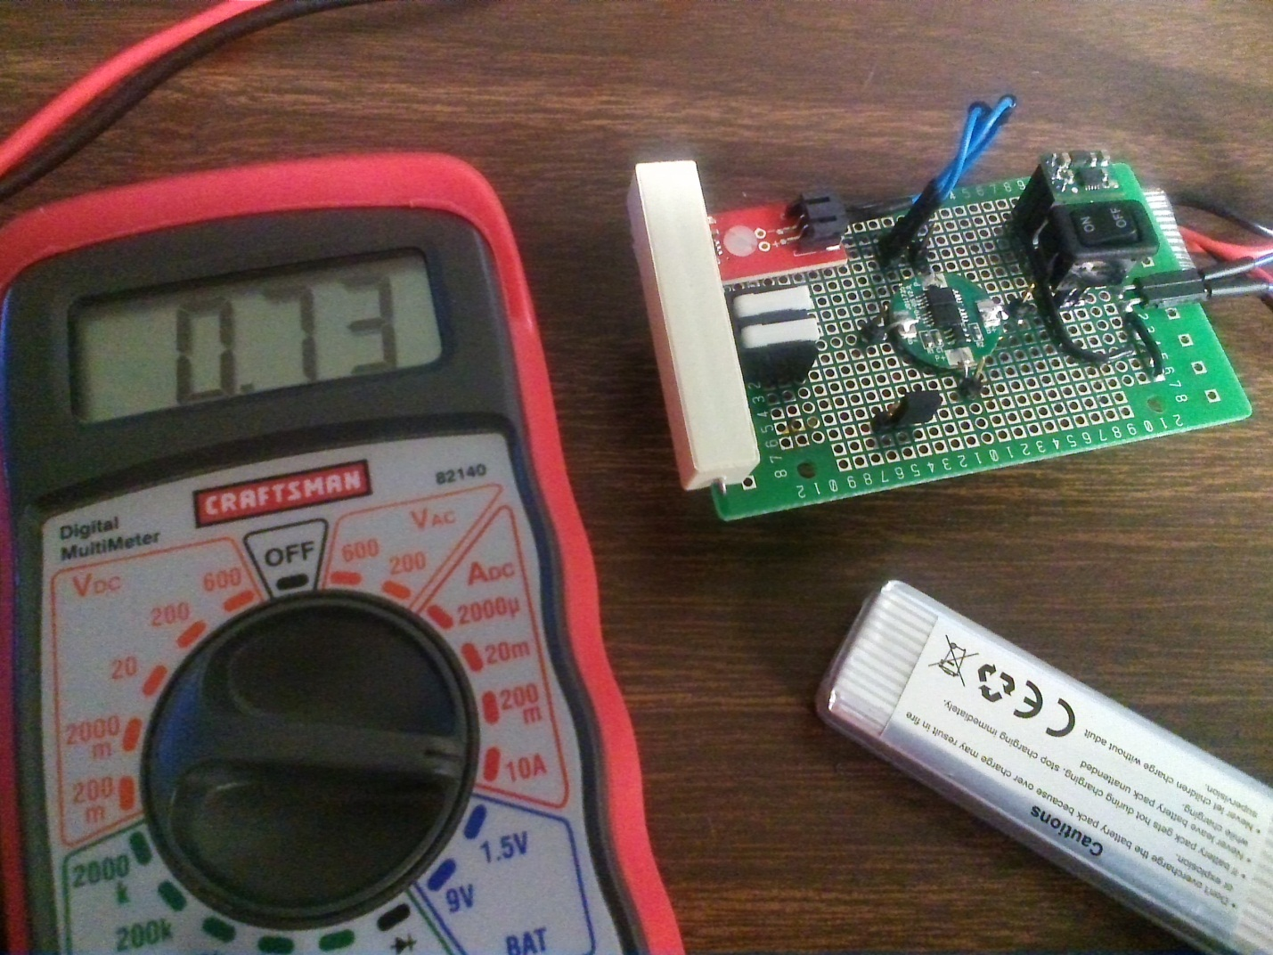

Figure2. Showing initial current draw of 730mA using ammeter function of multimeter.

**Charger**:

Test conducted at 7:15AM and finished at 11:45AM. The total time to charge is therefore 4.5 hours for a single cell 1600mAh LiPo under no load with a 500mA charger.

**Regulation**:

During two full discharge tests, SMPS “boost” regulator was stressed under high current draw (750mA – 1.3A) and was warm to the touch but maintained electrical integrity.